Practical 6. Demonstrate the creation and management of your digital
identity.
a) Create a social media profile (LinkedIn
preferred).
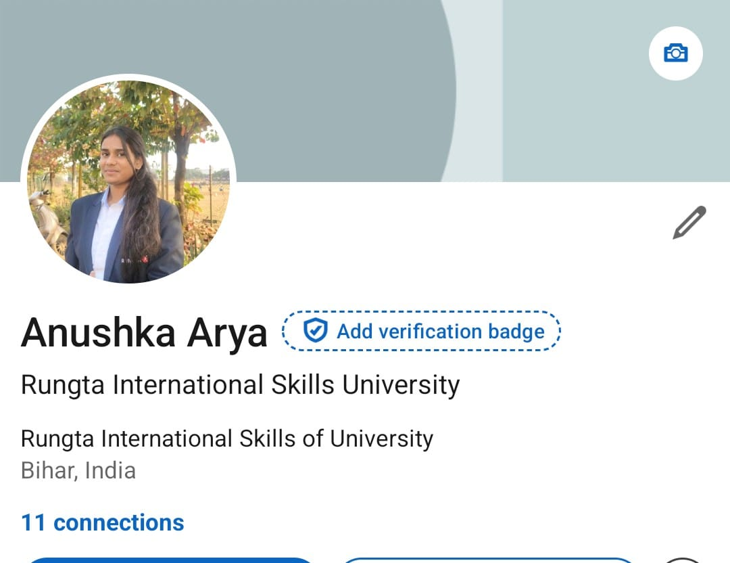
b) Add a profile photo, short bio, skills, and
education details.
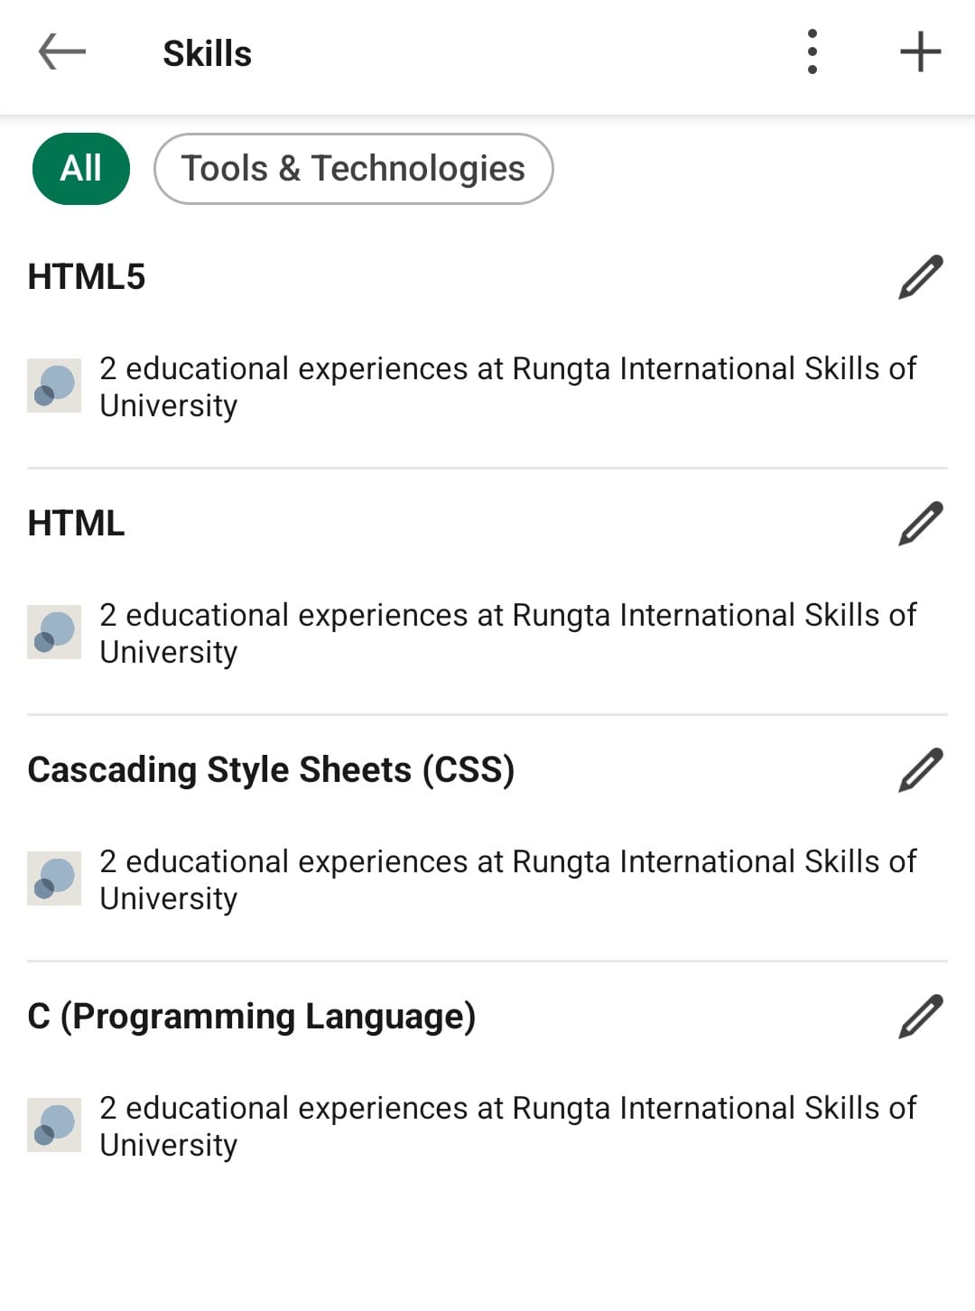
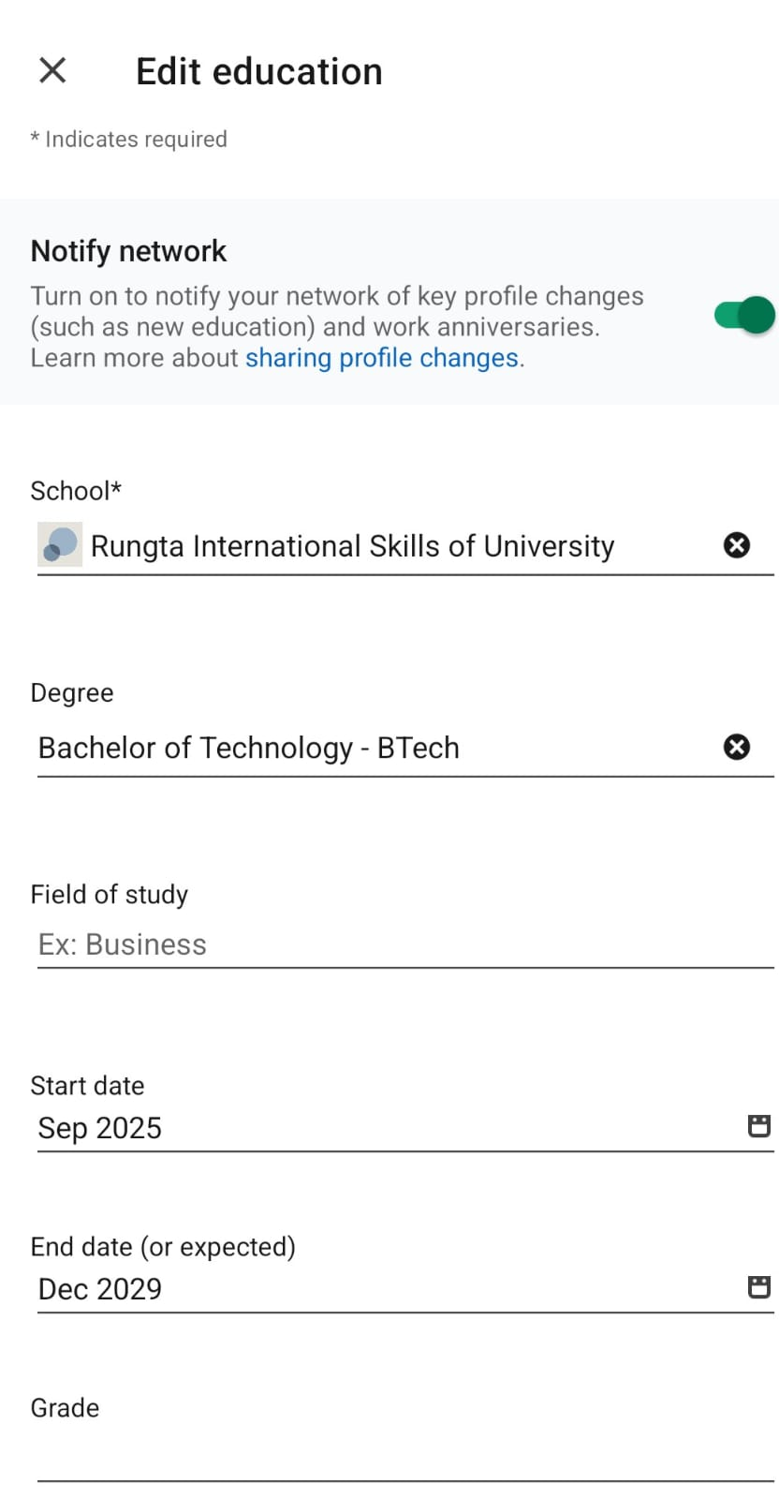
c) Create a simple post about “My Learning
Journey in Digital Literacy.”
